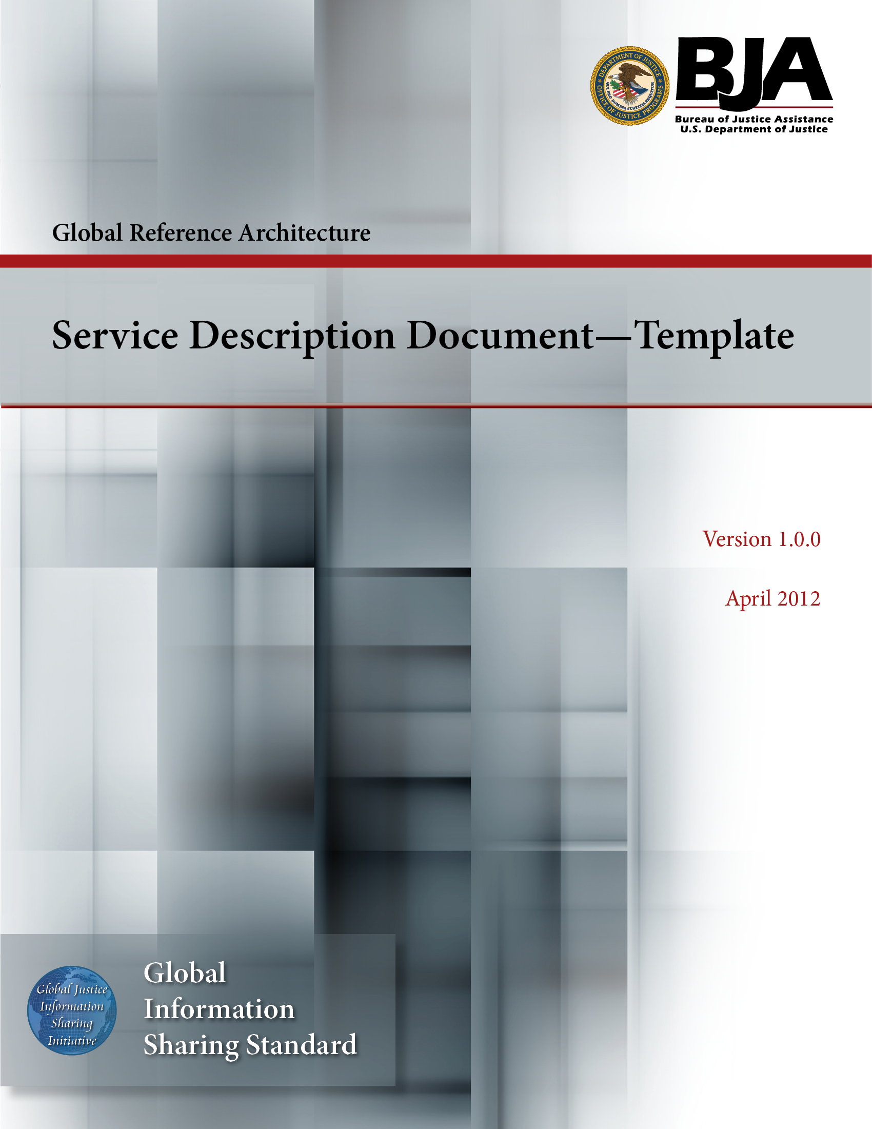


The Global Reference Architecture (GRA)

[Service Name] [Service Abbreviation] [Service Version]

Service Description Document (Template)

Version 1.0.0

By [Name of Organization]

[Month Year]

Table of Contents

Document Conventions iii
1. Introduction 1
2. Service Overview 2
2.1 Purpose 2
2.2 Scope 2
2.3 Capabilities 2
2.4 Real-World Effects 3
2.5 Summary 3
2.6 Description 3
2.7 Security Classification 3
2.8 Service Specification Package Version 4
3. Business Scenarios 4
3.1 Business Scenario 4
3.1.1 Primary Flow 5
3.1.2 Alternative Flows 5
4. Service Interoperability Requirements 5
4.1 Service Interaction Requirements 5
4.2 Service Assumptions 6
4.3 Service Dependencies 6
4.4 Execution Context 6
4.5 Policies and Contracts 7
4.6 Security 8
4.7 Privacy 8
4.8 Other Requirements 8
5. Additional Information 8
6. Service Model 9
6.1 Information Model 9
6.1.1 IEPD Reference 10
6.1.2 Data Inputs 10
6.1.3 Data Outputs 10
6.1.4 Data Provenance 10
6.2 Behavior Model 10
6.2.1 Action Model 11
6.2.2 Process Model 12
Appendix A—References 13
Appendix B—Glossary 14
Appendix C—Document History 15

Document Conventions

[Note: The following template is provided for use with the Service Development Process. Text enclosed in square brackets and/or displayed in blue is included to provide guidance to the author and should be deleted before publishing the document.]

Service Description Document Template

Introduction

In the context of the GRA and Service-Oriented Architecture [soa] in general, a service is the means by which one partner gains access to one or more capabilities offered by another partner. Capabilities generate real-world effects that can be as simple as sharing information or can involve performing a function as part of a complex process or changing the state of other related processes. Government organizations have numerous capabilities and a multitude of partner organizations, both inside and outside of their traditional communities. There are significant benefits for these organizations to share information and have access to each other's capabilities. Achieving interoperability among these organizations requires alignment of business and technical requirements and capabilities. In addition, it is critical to have a consistent way of specifying these requirements and capabilities and sharing them across organizational boundaries. The GRA was developed to facilitate interoperability and to assist in meeting other key requirements common in a complex government information sharing environment. In order to achieve interoperability, a consistent approach must be defined to identify, describe, and package services and their interactions in many different technical environments, across multiple government lines of business, at all levels of government, and with partner organizations.

The GRA defines a service interface as “the means for interacting with a service.” It includes specific protocols, commands, and information exchange by which actions are initiated on the service. A service interface is what a system designer or implementer (programmer) uses to design or build executable software that interacts with the service. That is, the service interface represents the “how” of the interaction. Since the service interface is the physical manifestation of the service, best practices call for service interfaces which can be described in an open-standard, machine-referenceable format (that is, a format which could be automatically processed by a computer).

A Service Specification is a formal document describing the capabilities made available through the service; the service model that defines the semantics of the service by representing its behavioral model, information model, and interactions; the policies that constrain the use of the service; and the service interfaces which provide a means to interacting with the service. A Service Specification is analogous to the software documentation of an Application Programming Interface [api]. It provides stakeholders with an understanding of the structure of the service and the rules applicable to its implementation. It gives service consumers the information necessary for consuming a particular service and service providers the information necessary for implementing the service in a consistent and interoperable way.

The main components of a Service Specification are the Service Description, one or more Service Interface Descriptions, and the schemas and the samples used to implement and test the service.
A Service Description contains information about all aspects of the service which are not directly tied to the physical implementation of the service; in other words, the service interface. A Service Interface Description is a description of the physical implementation; specifically, the service interface used in a specific implementation of the service. Since a service can leverage multiple Service Interfaces, the Service Specification might contain more than one Service Interface Description.

This document is designed as a template for developing a Service Description for a specific service and thus contributes to a consistent approach for describing services.

Service Overview

[The service overview section contains the scope and structure of the service being described. This section will explain why the service is needed and what it is intended to do, and relates the service to its business objectives. It should be clear and concise and targeted for a nontechnical audience. The questions that need to be answered in the service overview subsection are:

- What is the scope of the service and its capabilities?
- What are its real-world effects?
- What are the conditions under which this service is applicable?

This section should be treated as a narrative description of the service. The purpose of this section should be to provide a good understanding of the service and its actions for people who may have an interest in this service.]

Purpose

[This section provides a short textual description of the intended purpose of the service. This section aids the consumer in quickly determining whether the service being specified has applicability to the consumer’s needs.]

Scope

[This section defines the overall scope of the service and could enumerate the actions that the service supports. Additionally, this section identifies high-level items which are not in scope. ]

Capabilities

The capabilities of the service describe the means of providing business value by one partner to another partner. As defined by the GRA, each capability produces one or more real-world effects, each of which is an outcome of the business value sought by one of the partners.

Real-World Effects

[The real-world effects of the service describe the result of invoking the various actions of the service. As defined by the GRA, each capability produces one or more real-world effects, each of which is an outcome of the business value sought by one of the partners. A real-world effect can be either the obtaining of information, the changing of something of business relevance to the participating partners, or both. Because capabilities are implemented by provider systems, real-world effects consist of the business outcomes of provider systems. That is, real-world effects in the GRA are essentially the information made available by provider systems or the outcomes resulting from business processes and workflows automated by provider systems, or both.

Each action of the service can produce its own real-world effect; the aggregation of all the actions’ real-world effects is the service’s real-world effect. The Service Identification and Design Guidelines provides principles and guidance that govern the grouping of actions into services, ensuring cohesiveness and making a description of the service’s real-world effect practical. If the diversity of actions makes the service’s real-world effects difficult to describe concisely, the service should be refactored.]

Summary

[This section defines the conditions under which the service is relevant. It identifies likely service consumers and describes how the service is currently being used or is likely to be used. The purpose of this subsection is to assist the service consumer in making a decision of whether to utilize this service.

This section is limited to 160 characters including spaces.

The Description and Business Scenarios section will provide additional detail.]

Description

[This section defines in more detail the conditions under which the service is relevant. It identifies likely service consumers and describes how the service is currently being used or is likely to be used. The purpose of this subsection is to assist the service consumer in making a decision of whether to utilize this service.

The Business Scenarios section will provide additional detail.]

Security Classification

[This section lists any applicable classification of the security level of the information exchanged by the service, such as SBU, Secret, etc. If there is no strict classification, this section can contain a brief statement regarding the security of the data.]

Service Specification Package Version

[This section defines the Service Specification Package version under which this service specification is developed.]

[Additional artifacts related to this section's content can be provided in the artifacts folder of the service package.

[Service Abbreviation] SSP [Service Version]\artifacts

If such artifacts are provided, they should be referenced in this section. A description of the artifact and a link to it should be provided as part of the reference.]

Business Scenarios

[This section of the document provides a more detailed, but still high-level, narrative description that may be supported by industry standard modeling notation where appropriate. Again, care should be taken to be as clear and precise as possible and to define real scenarios that would be relevant to a significant number of organizations. This section presents the conceptual model for the actions supported by the service.

The business scenarios section should be used to identify the typical usage of the service in a context. This defines the primary flow. This would be similar to a high-level business use case, elaborated in technology-agnostic terms. If the business scenario has alternative flows, these should also be documented. Simple alternative flows can be documented in text within the primary flow. Complex alternative flows may need a separate section to describe the flow. It is recommended that diagrams be utilized to augment the narrative description of each business scenario. The use of BPMN, JIEM, UML, work and process flow models, or similar open-standard notation to develop the diagrams is recommended.

Ultimately, business scenarios will better describe the service than explanatory text, since they are illustrations of the role the service is envisioned to play. There is no need to identify and elaborate dozens of scenarios in this section.

A service description could contain more than one business scenario. In this case, this document will contain more than one business scenario section.]

Business Scenario

[A short description that briefly conveys the role and purpose of the business scenario. A single paragraph should suffice for this description. Every process and event flow should show the beginning or triggering event as the initial context statement of the flow.]

Primary Flow

[The GRA speaks of services in terms of system-to-system interaction. Often, the consuming system is simply mediating a human interaction; however, services are system-to-system and the information about the human actor is passed between systems. In describing the primary flow, start with the initiating system and describe what behaviors occur between systems. The business scenario describes what the initiating system does and what the partner system does in response. It is phrased in the form of a dialog between systems.

The business scenario should describe what happens inside the systems but not how or why. If information is exchanged, the use case should describe the messages that are passed back and forth.]

Alternative Flows

[More complex alternatives are described in a separate section, referred to in the primary flow subsection. The alternative flow subsections could be considered as alternative behaviors. Each alternative flow represents alternative behavior, usually due to exceptions that occur in the main flow. They may be as long as necessary to describe the events associated with the alternative behavior. When an alternative flow ends, the events of the main flow of events are resumed unless otherwise stated. Alternative flows may, in turn, be divided into subsections if that approach improves clarity. This section is optional.]

[Additional artifacts related to this section's content can be provided in the artifacts folder of the service package.

[Service Abbreviation] SSP [Service Version]\artifacts

If such artifacts are provided, they should be referenced in this section. A description of the artifact and a link to it should be provided as part of the reference.]

Service Interoperability Requirements

[While service descriptions are technology-agnostic and do not detail the physical model of a service, certain requirements need to be outlined to increase the likelihood of interoperability across services based on the same service description. This section outlines those requirements, describing the service interaction requirements, relevant assumptions and dependencies, and policies and contracts.]

Service Interaction Requirements

[This section describes any service interaction requirements which should be followed by the service interface to ensure service interoperability. The requirements in this section should be technology-agnostic and should not be specific to any service implementation. This section is intended to inform the interaction requirements section of the SIDD.]

Requirements | Mandatory (Yes/No) | Justification/Notes
Service Consumer Authentication
Service Consumer Authorization
Identity and Attribute Assertion Transmission
Service Authentication
Message Nonrepudiation
Message Integrity
Message Confidentiality
Message Addressing
Reliability
Transaction Support
Service Metadata Availability
Interface Description Requirements
Service Responsiveness

Service Assumptions

[This section lists all assumptions on which the service depends to deliver its real-world effects.]

Service Dependencies

[In many cases, services are orchestrated or choreographed together to perform a business function and deliver capabilities. This section lists and references all services, if any, which the service invokes directly in order to deliver its capabilities. The list of service dependencies represents only first-level correlations between services. In practice, this means that if the services invoked directly by the service and documented in the list of dependencies invoke other services to perform their tasks, these additional services are not included in the list of dependencies for the service. These additional services are included only in the list of the dependencies of the invoked services.]

Execution Context

[Service descriptions should include all information pertinent to the production or consumption of the service, including expected infrastructure functions and other dependencies. No information directly pertaining to implementation platform or technology should be included in the service description. Conversely, platform capabilities which are technology-independent should be included. For example, stating in the service description that services that are encrypted are being provided by the infrastructure is preferred compared to stating that the Public Key Infrastructure (PKI) infrastructure is expected. It is expected that the services defined using this document will minimize the dependence on specific technical infrastructure to provide the greatest flexibility and interoperability for service providers and service consumers.

It is also important to note that the information in this section will be applicable to more than one service, and these required capabilities will be provisioned as part of the infrastructure layer of the architecture. For instance, if information is to be exchanged securely within the execution context, enabling this functionality at the infrastructure level and not per a specific SSP or SIP is the strongly preferred direction for enabling the GRA. In other words, these commonly used technical functions would be most effectively achieved by an infrastructure solution which supports the GRA.]

Policies and Contracts

[Service policies and contracts express rules that govern the interaction between a service consumer and a service. A policy is an assertion by either a consumer or a service provider of that participant’s requirements for willingness to interact. Policies state conditions, obligations, and constraints. A contract is an agreement by the parties involved. Whereas a policy is an assertion by one participant in the interaction, a contract is an agreement between the participants that expresses some expectation or requirement of the interaction. And whereas policy enforcement is generally the responsibility of the participant who asserts the policy, contract enforcement may involve resolution of disputes that arise between the parties.

Services can be provided with simple policy statements that constrain the provider but not the consumer. This is true especially for the release of public information using non-mission critical services. However, it is likely that within the information sharing space, most services will require development of contracts that bind all parties. Some of these contracts will be service-specific; others will be umbrella memoranda of understanding or more detailed service agreements that relate to more than one service.

The Service Description should identify any existing memorandum of understanding or agreements that constrain the implementation of the service and should identify any policy requirements not otherwise covered by these umbrella agreements that are necessary for the service. The requirements from these documents should be included here in a technology-agnostic form.

Each service action can have distinct policy constraints that apply, though those elements should be amenable to aggregation into a single policy for the service. Future versions of this document will provide additional guidance on defining policy and contract requirements for the service and its actions at the service description level.]

Security

[While service descriptions are technology-agnostic and do not detail the physical model of a service, certain security requirements are applicable to the service and need to be carried through all its implementations. This section outlines those requirements.]

Privacy

[While service descriptions are technology-agnostic and do not detail the physical model of a service, certain privacy requirements are applicable to the service and need to be carried through all its implementations. This section outlines those requirements.]

Other Requirements

[This section lists any other requirements which have to be met and on which the service depends to deliver its capabilities.]

[Additional artifacts related to specific subsections of this section's content can be provided under the artifacts folder of the service package. It is suggested there be a large number of artifacts related to this section. These artifacts are included as documents or folders under the various artifacts subfolder of the artifacts folder.

[Service Abbreviation] SSP [Service Version]\artifacts\various artifacts\*

If such artifacts are provided, they should be referenced in this section. A description of the artifact and a link to it should be provided as part of the reference.]

Additional Information

[This section contains any additional information pertinent to the service which should be included in this document but does not belong in the document sections above. This could be information about future capabilities the service could provide, information regarding specific conditions which govern the use of the service, information regarding specific domain capabilities the service fulfills, etc. If required, subsections can be created to further structure the information provided in this section.]

[Additional artifacts related to this section's content can be provided in the artifacts folder of the service package.

[Service Abbreviation] SSP [Service Version]\artifacts

If such artifacts are provided, they should be referenced in this section. A description of the artifact and a link to it should be provided as part of the reference.]

Service Model

[Ultimately, the service description requires a detailed elaboration of each action the service is capable of performing. This section describes the inputs, outputs, and behavior of the service and its actions. The requirements for such detailed information are addressed by the concept of a service’s information model and behavior model, collectively called the service model in the GRA. The concepts of the information and behavior models are described in the subsections which follow.

It is essential for the service model to describe what the service will be doing but not how it is expected to perform the function. Implementers of the service must have freedom to innovate, and overspecification can render a model to be of little value.

Analysts must ensure that the service is adequately specified so that it performs as expected across multiple implementation approaches and technologies and still provides the intended functionality. The service description should also be able to stand on its own regardless of any technical specification or implementation. As a result, this section must be precise. For example, input/output parameters identified should be designated as mandatory or optional and related to specific data types, semantics, and structure as appropriate.
The following rules of thumb should be followed when documenting the detailed description of the service model:

- In the event interoperability is compromised if something is deferred to implementation, it should be included in this document.
- If there is an expectation within the information sharing community that a behavior or information construct behave a certain way, it should be specified in this document.]

Information Model

[The Information Model describes the data which comprises the inputs and outputs of the service and its actions. Information content representations (logical description) of the inputs and outputs should be represented in a platform-agnostic formalism. Industry open-standard notation (e.g., UML) is preferred to represent the information model.

The following principles shall be followed for specifying the information model:

  - Reference use of the National Information Exchange Model (NIEM) if possible.
  - Existing NIEM IEPDs should be used and/or extended when possible. These IEPDs should be described in a high level in this section and placed in the respective information model folder of the service package.

If certain constraints dictate the use of non-NIEM information content, conformance to the NIEM MPD and the NIEM NDR is recommended.]

IEPD Reference

[This section identifies any IEPDs that exist and are to be used either as references for further development/enhancement or as-is. All IEPDs referenced in this section should be included in their entirety in the information model folder of the service package. The schema files also should be included in the schemas folder of the service package. Sample files should be included in the samples folder of the service package.]

Data Inputs

[Enumerate all data inputs, both mandatory and optional, and provide a logical representation. This section is intended to summarize the data inputs of all service actions and is not mandatory if the data inputs are described in detail under each action.]

Data Outputs

[Enumerate all data outputs, both mandatory and optional, and provide a logical representation. This section is intended to summarize the data outputs of all service actions and is not mandatory if the data outputs are described in detail under each action.]

Data Provenance

[Provenance is defined as the agency, office, or person of origin of records, i.e., the entity that created, received, or accumulated and used the records in the conduct of their business activities. Any applicable provenance information or restrictions should be provided in this section.]

[Additional artifacts related to this section's content can be provided in the service model folders of the service package.

[Service Abbreviation] SSP [Service Version]\artifacts\service model\information model

If such artifacts are provided, they should be referenced in this section. A description of the artifact and a link to it should be provided as part of the reference.]

Behavior Model

[The behavior model describes the behavior of the service. The behavior model consists of two components—action model and process model.]

Action Model

[The action model defines the operations available to consumers (in effect, what the service “does”). This normally needs to be done in the context of a process model (see below). Each action may utilize part or a subset of the service information model.

It is recommended that the following table be used to describe each action.

Action Name | [Action Name]
Action Purpose
[Action Purpose]
Action Inputs | Action Outputs
[Action Inputs] | [Action Outputs]
Action Provenance
[Action Provenance]

The following information should be documented for each action.

Action Name

[The action name assists in the discovery of the service. It enables both the service consumer and the service provider to locate services and actions in the services directory.

The action name is usually in the active and describes an action that can occur against the service. The service name is usually not identified but is implied in the service action name.]

Action Purpose

[This section should contain a concise explanation of the action’s overall purpose and functional context.]

Action Inputs

[Define the subset of the action’s allowable (mandatory and optional) input value(s) and associated constraints. Reference should be made to the information model described above.]

Action Outputs

[Define the subset of the action’s allowable (mandatory and optional) output value(s) and associated constraints. Reference should be made to the information model described above.]

Action Provenance

[Define any specific for this action provenance information. Reference should be made to the information model described above.]

Process Model

[Process models define how consumers may invoke the service’s actions together or in a sequence to accomplish some larger business process. They do not describe the process of interaction among multiple services within a business process.

Process models describe processing rules and fault handling and should provide a step-by-step description of the logic carried out by the service actions including any pre- or post-conditions. This should be supplemented with algorithms, workflow diagrams, or even entire business process definitions.

The process model could be described utilizing variety of business process modeling notations and languages which are further described in business process modeling profiles. Listed below are some commonly used process modeling profiles:

- BPMN profile
- JIEM profile
- UML profile

All processing model profile artifacts used to describe the service should be made available in the behavior model folder of the respective service package folder.]

[Additional artifacts related to this section's content can be provided in the service model folders of the service package.

[Service Abbreviation] SSP [Service Version]\artifacts\service model\behavior model

If such artifacts are provided, they should be referenced in this section. A description of the artifact and a link to it should be provided as part of the reference.]

Appendix A—References

[This section is used to list applicable references.]

[Reference name and description] | [Fully qualified link/path to the reference information]

Appendix B—Glossary

[This section is used to list glossary terms used in the document.]

[Glossary term or acronym] | [Glossary term or acronym description]

Appendix C—Document History

[This section is used to document the history of the service description document.]

Date | Version | Editor | Change



